**Learning Center- Word Shapes**

**Activity: Write the correct words in the boxes**

climbed up



|  |  |  |  |  |  |  |  |  |
| --- | --- | --- | --- | --- | --- | --- | --- | --- |
| called | jumped | | missed | | felt | | banged | |
| fell | | ran | | broke | | crashed | |

|  |  |
| --- | --- |
|  |  |
|  |  |
|  |  |
|  |  |
|  | |

**Learning Centre: Dalal’s Story**

**Activity: Listen to the story and fill the gaps with past tense verbs:**

**broke- ran- jumped - crashed – called - banged - broke**

Once upon a time, there was a girl called Dalal.

On Monday, Miss Naila said to her: “Dalal, why didn't you come to school yesterday?”

Dalal said: “...Ummm, I wanted to come to school, but my cat **________** out of the window and **_________** its head and **_________** its leg, and I **_________** the doctor and the doctor said: this cat needs to stay at home, so I stayed at home too and helped.”

On Wednesday, Miss Naila said to Dalal: “Dalal, why didn’t you come to school yesterday?”

Dalal said: “...Ummm, I wanted to come to school, but my brother **________** into the street and **________** into a tree and **________** his arm, and I called the doctor and the doctor said: this boy needs to stay at home, so I stayed home too and helped.”

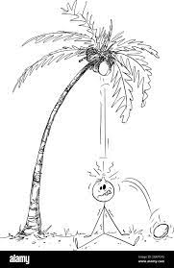

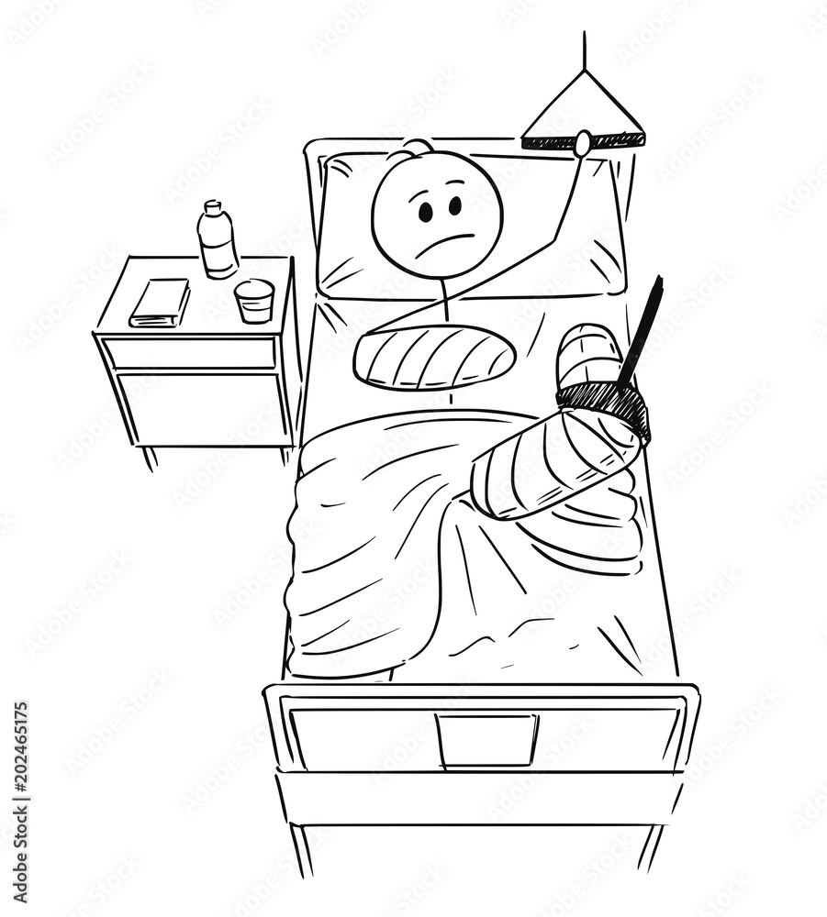

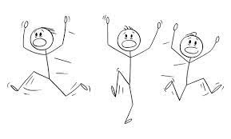

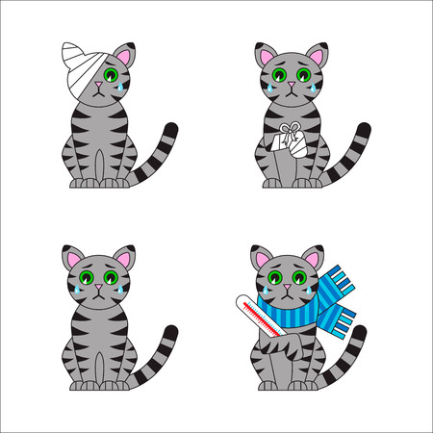



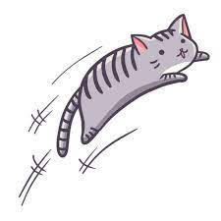

**Learning Centre: Present and Past Tense Verbs**

**Activity: Look around the room for 20 cards then match the past tense with the present tense verbs!**

**Example:**

|  |  |
| --- | --- |
| **Call** |  |
|  | **Called** |