Unit 10- Technology
Vocabulary
Word | Meaning | Picture | Sentences
ancient | قديمة جدا | 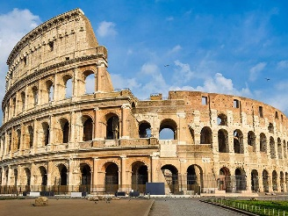 | The colosseum is an ancient building. It is 1953 years old.
civilization | حضارة | 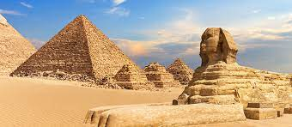 | The Pyramids are from the Egyptian Civilization.
example | مثال |  | Red is an example of a colour.
find out | اكتشف |  | Let’s find out about ancient Egypt.
history | تاريخ | 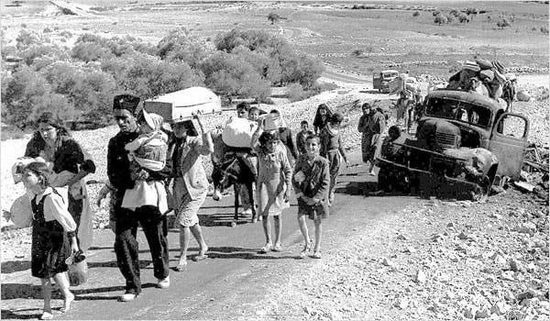 | We study about 1948 in our history lessons.
machine | الة |  | Machines help humans complete difficult jobs.
pump | مضخة | 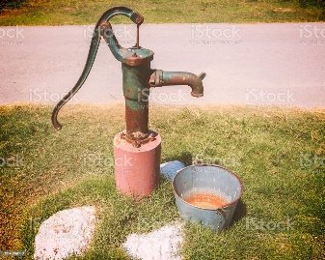 | Egyptians invented the first water pump.
radio | راديو | 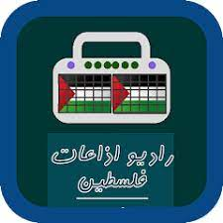 | I love listening to the radio in the car.
think back | استرجع بذاكرتك | 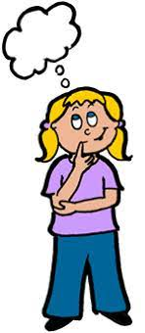 | Think back to when you were young; who were your friends then?
make a call | اجري مكالمة |  | I have to make a call to my mum and tell her I will be late.
send a text | ابعث رسالة |  | I will send you a text when I get there.
have a chat | نقوم بالدردشة |  | My friend and I have a chat online every night.
We use | نستخدم | 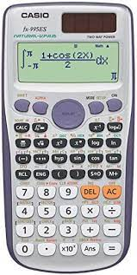 | We sometimes use a calculator in exams.
simple machine | الة بسيطة | 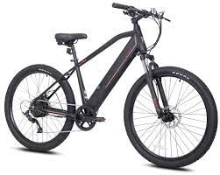 | The bike is an example of a simple machine.
advanced machine | الة متقدمة | 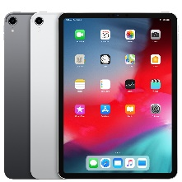 | iPads are examples of advanced machines.
Grammar
Reported Speech
Reported speech is when we tell someone what another person said. To do this, we can use direct speech or indirect speech.
Direct speech | Indirect speech
“I work in a bank,” said Daniel.  She said, “I love the Toy Story films!”  'I have an interview at four o’clock,' she said.  'I am tired of studying,' he said. | Daniel said that he worked in a bank.  She said she loved the Toy Story films.  She said she had an interview at four o’clock.  He said he was tired of studying.
Rules:  You write the exact words between quotation marks.  There must be an end mark at before the last quotation (, . ? !) | Rules:  Verbs in the present simple change to the past simple.  (advanced rules taught in coming years)
Exception: when someone is talking about a fact that doesn’t change.
She said, “The sun is a star.” (direct)
She said that the sun is a star. (indirect)

Exercise: Change the following sentences from direct speech to indirect speech and vice versa.
- He said, “I want to visit different countries.”
_____________________________________________________________________

- Mum shouted, “I don’t want to see the room untidy!”
_____________________________________________________________________

- “Ï love Jerusalem,” said the visitor.
_____________________________________________________________________

- “Ï am late because there is a lot of traffic.” Said my friend.
_____________________________________________________________________

- My father said that phones are important.
_____________________________________________________________________

- They said that they lived in that building.
_____________________________________________________________________

