Unit 10- A Trip to the Dead Sea
Vocabulary

Word | Meaning | Picture | Sentences
anywhere | في اي مكان |  | I couldn’t find my phone anywhere in the house.
mud | طين | 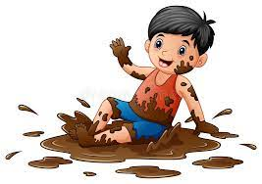 | My little brother likes playing in mud.
below sea level | تحت مستوى البحر | 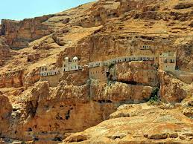 | Jericho is below sea level.
desert | صحراء | 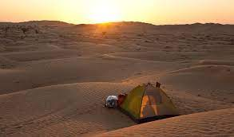 | I like camping in the desert.
ever | في اي وقت مضى | 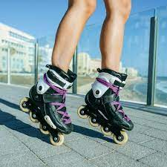 | Have you ever tried skating?
gazelle | غزال |  | We saw a gazelle near Hizma.
jerboa | الجربوع | 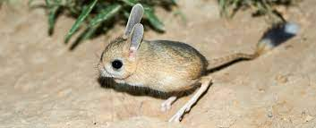 | I am scared of jerobas!
oasis | واحة | 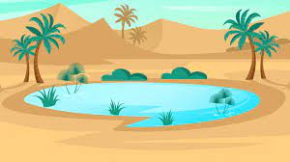 | We stopped at an oasis to drink some water.
palm tree | شجرة نخيل | 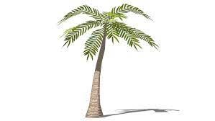 | My grandmother has a lot of palm trees in her farm.
rock | حجر | 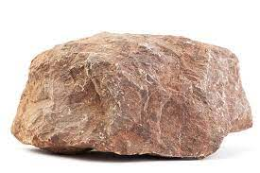 | I got a pink rock from Petra.
salty | مالح |  | The water is salty in the Dead Sea.
skin | جلد | 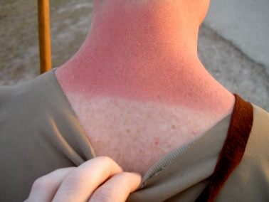 | The sun burnt my skin!
spring | نبع | 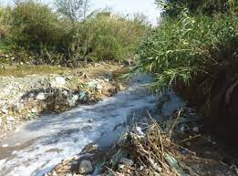 | We use water from the spring for our plants.

Grammar
Present perfect vs Past simple
What is the difference?
Past Simple | Present Perfect
Before Ahmed came to our city, he was in Jordan.  His mum got a new job, so the family moved here.  When I met Ahmed, he knew nothing about Jerusalem. | My friend Andrew has lived in this city for five years.  We have been best friends since then.  His dad says he has learned a lot from me.
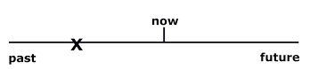 | 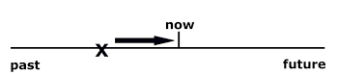
حدث في الماضي و انتهى. | حدث بدأ في الماضي لاكن لا يزال قائم.

Exercise 1: Add “have” or “has” to complete these sentences:
- Present perfect tense uses the verb have/has before the main verb.
- Use ‘have’ for I / you/ we/ they.
- Use ‘has’ for he/ she/ it.

- My friend Alia lived in Palestine for ten years.
- We been best friends all that time.
- Unfortunately, the cat been sick on the carpet!
- Mum asked, “Where you been all this time?”
- Sports Day been postponed because of the rain.
- every person chosen a partner now?
- ________ they been studying?
- I ______ been at the club since this morning.

Memory Match
Activity: Cut out the cards.
Mix up the cards and spread them out face down.
Ask students to turn up two cards at a time to find the matching verbs.
To make the game more interesting ask students to put the present perfect tense verbs in correct sentences before they can win/keep the cards.

do | has done | go
has gone | fly | has flown
eat | has eaten | drink

has drunk | swim | has swam
visit | has visited | make
has made | walk | have walked
see | have seen | be

have been | live | have lived
give | has given | take
has taken | walk | has walked
play | have played

