**The Emperor’s New Clothes**

By Hans Christian Anderson

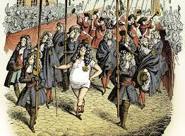

**Summary:** There once was an emperor who cared about nothing but himself. The emperor loved to wear expensive and unique clothes.

One day, two strangers met the emperor and convinced him that they will be able to weave the best fabric he has ever had. A special fabric that only the clever and wise can see but that is invisible to those who are dumb and simple.

The emperor was tricked and convinced! He walked around the city naked, showing off his new clothes. Nobody dared to challenge the powerful emperor except for a young boy who shouted: “The emperor is wearing no clothes!”

**Activities:**

**Speaking and Listening:** Have you got a favourite outfit? What does it look like? Did you choose it or did someone give it to you? Is it old or new? Tell us about your favourite outfit.

**Arts and Crafts:** In groups, design a new school uniform. Display your designs and vote for your favourite one.

**Reading and Writing:** Complete the following activities to learn about different **clothes** and **colours.**

**Colours and Clothes**

**Activity 1: Write the color!**

red blue yellow black green white

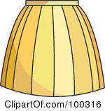 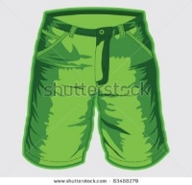 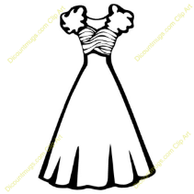

**__________________ __________________ ________________**

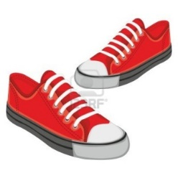 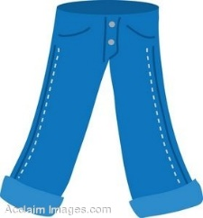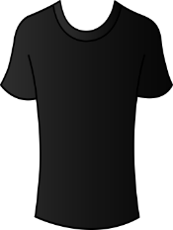

**___________________ ___________________ ________________**

**Activity 2: Circle the right answer!**

|  |  |
| --- | --- |
| Shorts Skirt | Shoes T-shirt |
| Jeans Shoes | Shorts T-shirt |
| http://www.clker.com/cliparts/6/f/9/8/11971486291056358595DigitaLink_Blank_T-Shirt.svg.hi.png Skirt T-shirt | http://bestclipartblog.com/clipart-pics/dress-clipart-4.jpg Jeans Dress |

**Activity 3: Write the missing letters!**

 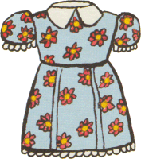 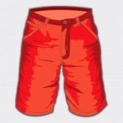

sk__ r__ dr__ss sh__r__s

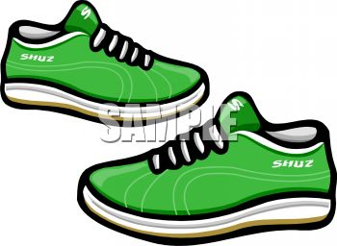 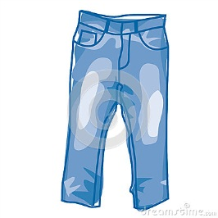 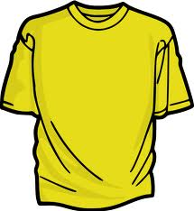

sh__ __s j__ __n__ t-sh__r__

**Activity 4: Colour the clothes**

|  |  |
| --- | --- |
| https://encrypted-tbn2.gstatic.com/images?q=tbn:ANd9GcRghcyGC2W2dzpE4olG7u4zsp6Bs5X6PAj-4DfGG-0W2dStSFZVRed T-shirt | http://www.discountmugs.com/discountmugs/upload/cliparts/images/babydressupshoes_1300733091.jpgBlack shoes |
| http://www.arthursclipart.org/clothing/modern/DRESS4.gif Yellow dress | http://thumbs.gograph.com/gg54480560.jpg Blue jeans |
| http://image1.masterfile.com/em_w/04/16/30/400-04163002w.jpg Green shorts | http://www.clker.com/cliparts/f/d/6/3/1341372161571989934skirt%202-hi.pngWhite skirt |