Activity 1- Word Cloud
Create a word Cloud using the following words. You must spell them correctly each time!
name, family name, mother, father, grandfather, grandmother, sister, brother
Example:
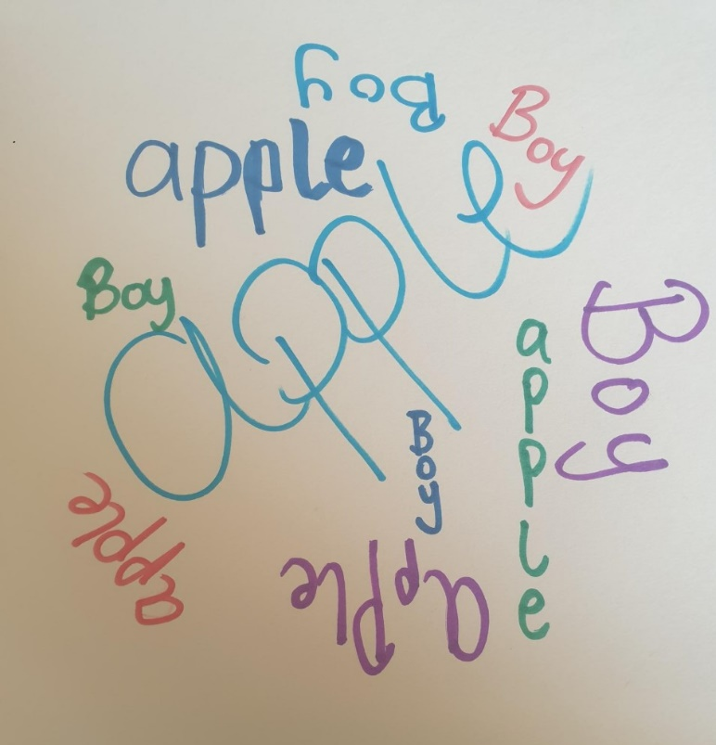

Activity 3 - Different Families

Family 5
The Eweisat family are from Jabal-Al-Mukaber; they have a grandfather, a mother, a brother and a sister.

Family 4
The Abu-Rahma family live in Ramallah; they have a grandfather, a mother, a father, a sister and a brother.

Family 3
The Murad family are from Jerusalem; they have a grandmother, a mother, a brother and a sister.

Family 2
The Allan family live in Sheikh Saad; they have a grandfather, a grandmother, a mother, a father and a sister.

Family 1
The Al-Sheikh family have a grandmother, a grandfather, a mother, a father, a sister and a brother; they live in Jerusalem.

Activity: Write about your family.
Write about your family members using the new words.
Example:  My name is Ali  My family name is Jafari.  I have one brother and two sisters.  My father’s name is Ahmed and my mother’s name is Fatma.  My grandfather’s name is Abed and my grandmother’s name is Layla. | 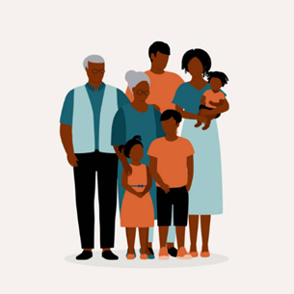

My family
- My name is __________ .
- My family name is ________ .
- I have_________ ____________ and ____________ ___________ .
- My __________ name is __________ and my ________ name is ___________.
- My __________ name is __________ and my __________ name is __________.

