Unit 1-My Summer Holiday
Vocabulary

Word | Meaning | Picture | Sentences
accident | حادث | 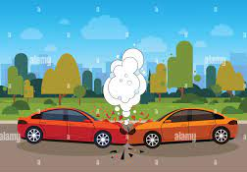 | We had an accident on the way to Jericho.
awful | مُريع |  | My socks smell awful at the end of the day.
Came back | رَجِع | 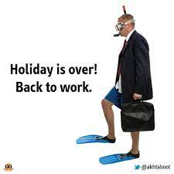 | We came back to school on 28th August.
Banged | ضَرَبْ | 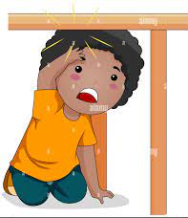 | I banged my head when I was trying to get my pencil, under the table.
Called | تَحَدثْ | 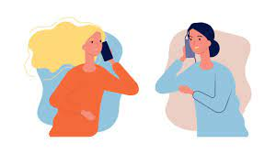 | I called my friend after school.
Crashed | صَدم | 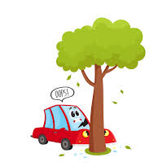 | We crashed into a tree.
Fell | وَقع | 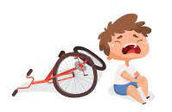 | The boy fell off his bike.
Jumped | قَفز | 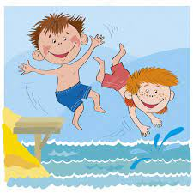 | We were so excited we jumped into the pool.
Rescued | انقذ | 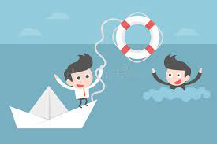 | My friend rescured me from drowning.
Climbed up | تَسلق | 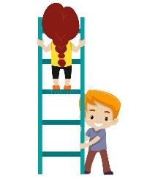 | I helped my sister when she climbed up the stairs.
Missed | إشتاق |  | I missed the Summer this morning.
Stairs | درج | 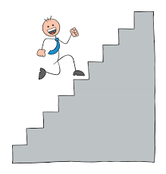 | I like going up the stairs more than taking an elevator.
still | ثابت | 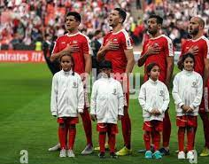 | We have to stand still when we hear the national anthem.
summer | صيف | 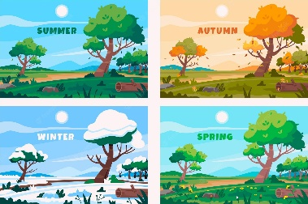 | Summer is the best season.
camp | مخيم | 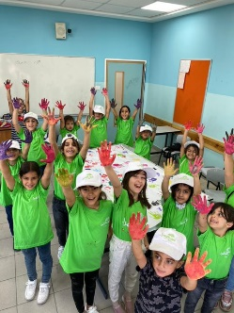 | We loved the Summer Camp at our school.
tired | مُرهق | 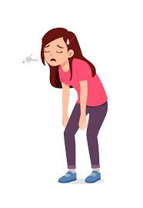 | I felt so tired after school.

