Unit 17: what will happen?
Let’s fill in the blanks!
travel grow wear live use rescue

One hundred years from now… مئة سنة من الآن
- People will ____________ spacesuit. 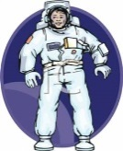
- People will ____________ by spaceship.
- Everyone will ____________ cheap and light computers.
- Scientists will ____________ new plants.
- Robots will ____________ people. 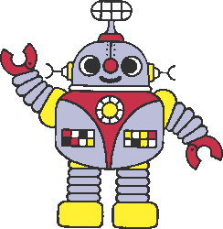
- People will ____________ on the moon. 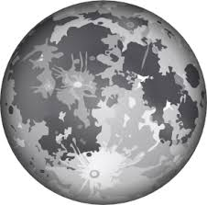

What will you be in the future?
I will be a doctor.
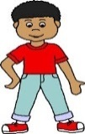
Q: What will you be in the future? ماذا سوف تصبح\تصبحين في المستقبل؟
A: I will be a doctor. سوف أصبح طبيبة
Q: What will you be in the future?
A: _______________________________________________.
Will: سَوْفَ
Won’t: لن
Let’s write true or falese X:
______ children will learn in schools.
______ people won’t travel to outer space.
______ robots won’t help rescue us.
______ scientists will grow new plants in science labs.
______ children won’t play all day.
Let’s write the vocabulary under the picture!

  

