Grade 8
Revision
Keywords
Word | Meaning | Picture | Sentence
because | لأن | 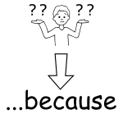 | I go to school because I want to learn.
brave | شجاع | 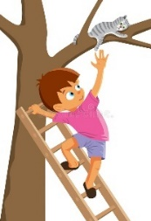 | Saif was brave when he saved the cat.
i don’t mind | أنا لا أمانع |  | I don’t mind helping my mother with the bags.
friendly | ودي | 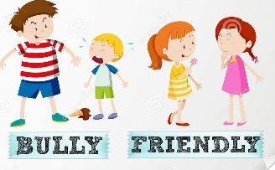 | Laila is friendly because she talks to everyone.
generous | كريم | 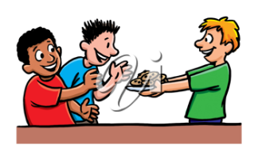 | Kareem is generous and always shares his food.
hate | يكره |  | I hate cucumbers but love tomatoes.
helpful | يساعد الآخرين | 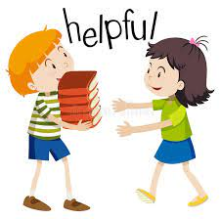 | My friend is helpful because she helps me carry the books to class.
honest | صادق | 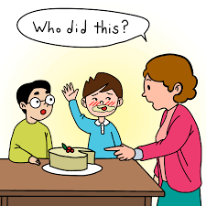 | Ahmed is honest because he told mum he ate the cake.
hope | آمل |  | I hope to go on holiday soon!
kind | لطيف | 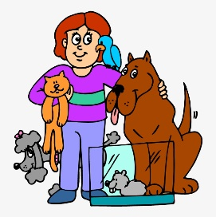 | My mother is very kind and loves animals.
polite | مؤدب |  | You are polite because you say hello and good morning when you meet others.
promise | أتعهد | 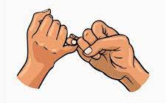 | I promise to work hard and study for the exams.
shout | تصرخ |  | Do not shout!
tell lies | أن تقول الأكاذيب | 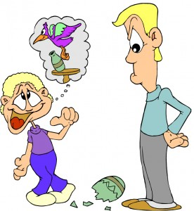 | Omar tells lies because he told his dad that a bird broke the bottle.
agree to | توافق على |  | They agree to work together.
I disagree  He/She disagrees | أنا لا أوافق |  | I disagree, cats are better than dogs.  He disagrees, cats are better than dogs.
I agree  He/She disagrees | أوافق |  | I agree, Jerusalem is beautiful.  Rafif agrees, Jerusalem is beautiful.

Grammar: To Want
I want to  He wants to  She wants to  They want to  We want to | I don’t want to  He doesn’t want to  She doesn’t want to  They don’t want to  We don’t want to

Complete the following sentence:
- Ali _______ ________ ___ swim in the sea. | 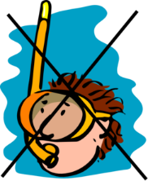  swim
- They _______ ___ swim in the sea. | swim
- Sahar ________ ___ learn English. | 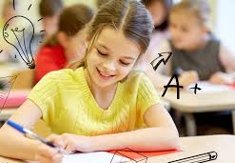  learn
- The boys _______ _______ ___ learn online. | learn
- Ali _______ ___ write a book when he grows up. | write
- We _______ _______ ___ write in P.E. We want to play! | write
- My father ________ ______ ___ go to the mall. | go
- My mother _______ ___ go to the mall. | go

The same rule can apply to (like, love, hate)
Examples:
Rula likes to sing.
My brothers like to sing.
Mohammed doesn’t like to sing.
The boys don’t like to sing.
Using “Agree and Disagree”
Ronaldo  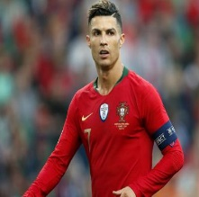 | Mohammed Salah  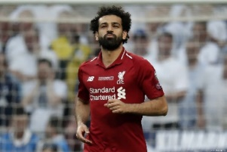

Name | Age | Country | Team | Goals in 2021-2022 | Salary  $
Ronaldo | 36 | Portugal | Manchester United | 22 | 26 million
Mohamed Salah | 29 | Egypt | Liverpool | 32 | 10 million

Exercise 1: Complete the sentences:
- Ronaldo is ___________ years old.  - Ronaldo is from ___________.  - Ronaldo plays for __________.  - Ronaldo scored _____goals in 2021/2022.  - Ronaldo makes ________ million dollars a year. | - Mohamed Salah _____ 29 years old.  - Mohamed Salah ____ ________ Egypt.  - Mohamed Salah _____ ____ Liverpool.  - Mohamed Salah _________ 32 goals in 2021/2022.  - Mohamed Salah __________ 10 million dollars a year.

Exercise 2: Write two sentences using agree and disagree.
Ronaldo is better than Mohamed Salah.

I agree Ronaldo is better because ……
I disagree, Mohamed Salah is better because……

I think Ronaldo is better because ……
I think Mohamed Salah is better because….

________________________________________________________________________________________________________________________________________________________________________________________________________________

