Unit 15- The “Best of Palestine” Tour
Vocabulary
Word | Meaning | Picture | Sentences
Tour | جولة | 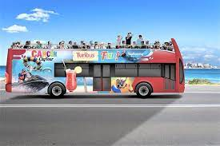 | My family and I took a bus tour around Istanbul.
Travel | ان يسافر | 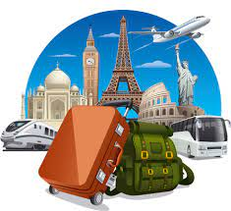 | People like to travel by plane.
Meet | ان يلتقي | 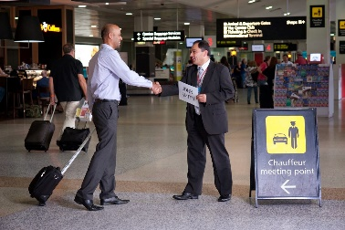 | The tour guide will meet us at the airport.
Float | ان يطفو | 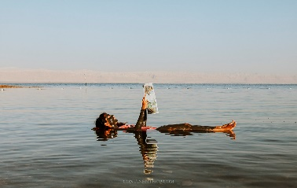 | Tourists like to float in the Dead Sea.
Ruins | أنقاض | 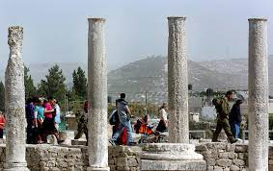 | We are going to see the ruins in Sabastia.
Arrive at | الوصول الى | 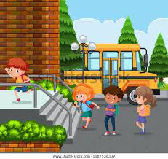 | We arrive at school at 8 am in the morning.
Leave | ان يترك | 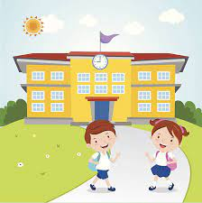 | We leave school at 2 pm.
Next to/near | بجوار\بالقرب من | 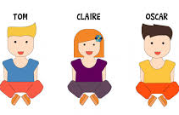 | Claire is next to Tom.  Oscar is near Tom.
Before | قبل | 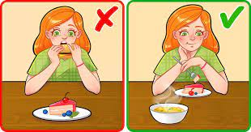 | It is better to eat a meal before dessert.
Tomorrow | غدا | 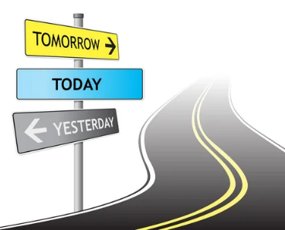 | We are going to Nablus tomorrow to visit my aunt.
Our | ملكنا | 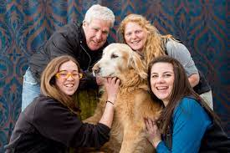 | Our dog is big and friendly.

Speaking
Guess what I am going to do- Game
- Divide the students into pairs.
- Give each pair a set of cards. Ask them to shuffle the cards and place them face down in a
pile.
- The first student picks up the top card and tells their partner one thing they are going to do to
prepare, before they start doing the planned activity on the card.
- Their partner tries to guess what they are going to do. They cannot say the underlined word.
Example:
A: I’m going to read my textbook.
B: You are going to have an exam.
A: Correct!
- If their partner is wrong, the student gives them another clue. The first student can give up to
three clues. If their partner guesses correctly, they keep the card. If not, the first student
keeps the card.
- Then, they switch roles and continue with a new planned activity card.

You are going to watch TV | You are going to bake a cake | You are going to ride my bike
You are going to go on holiday | You are going to meet a friend | You are going to your grandmother’s house.
You are going to buy new clothes. | You are going to a wedding. | You are going to play football.

