Unit 10- Ben and Amy’s Holiday
Vocabulary

word | Meaning | Picture | Sentences
wedding | عرس |  | We went to my uncles wedding last Friday.
princess | أميرة |  | Princess Haya is wearing blue.
palace | قلعة |  | The palace is big and has ten rooms!
mum | ام |  | I love my mum because she is caring.
dad | أب |  | I love my dad because he is kind.
grandfather | جد |  | My grandfather wears glasses.
grandmother | جدة | 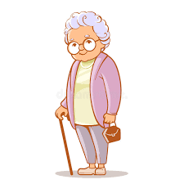 | My grandmother likes to go shopping.
family | عائلة |  | My family is made up of mum, dad, my sister and brother.
car | سيارة |  | I come to school by car.
beach | شاطئ |  | I want to go to the beach in the summer.
mountains | جبال | 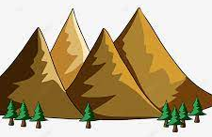 | The mountains are high.
travel | ان اسافر | 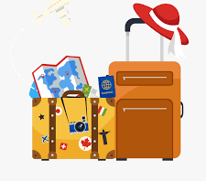 | I love to travel with my family.
Get married | سوف يتزوج\تتزوج | 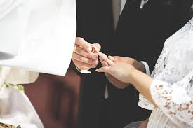 | My sister will get married in the summer.
look like | يشبه | 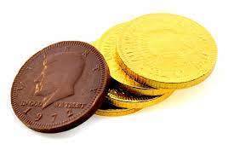 | This chocolate looks like gold coins.
about | عن | 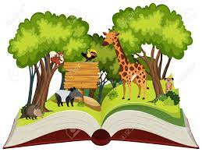 | This book is about animals
also | وهوأيضا |  | . This ice-cream is big, it is also delicious!
hour | ساعة(ستون دقيقه) |  | I will meet you at the café in an hour.
all | كل\جميع | 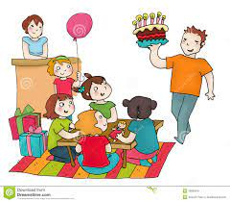 | All my friends came to my birthday party.
again | مرة اخرى |  | I did not win the game and had to try again.
for | لمدة |  | I have been studying for a week!
by | على | 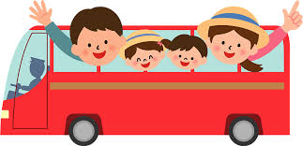 | We go to Jordan by bus.

Reading Comprehension
Ali’s Long Weekend
Ali
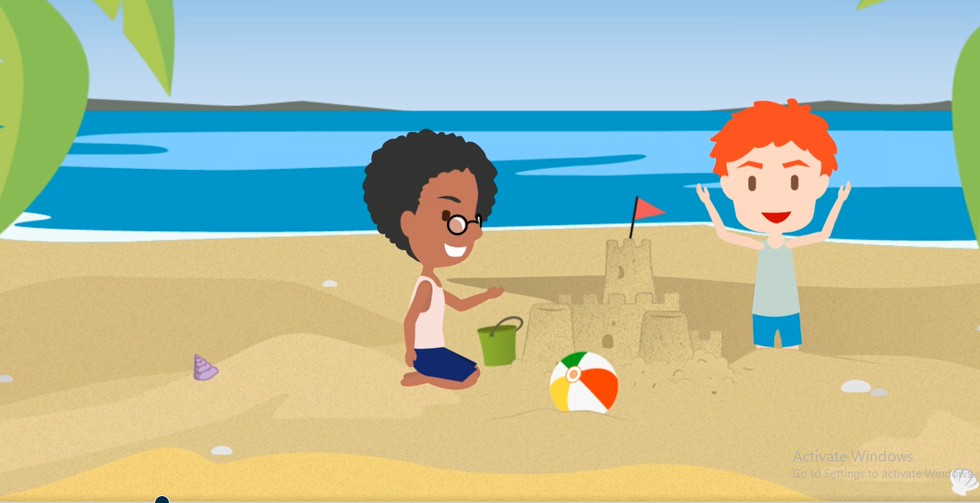
On Friday I was at the beach
With my best friend Baraa
We built a palace from sand all day
Until the sky was dark.
On Saturday we were at the funfair
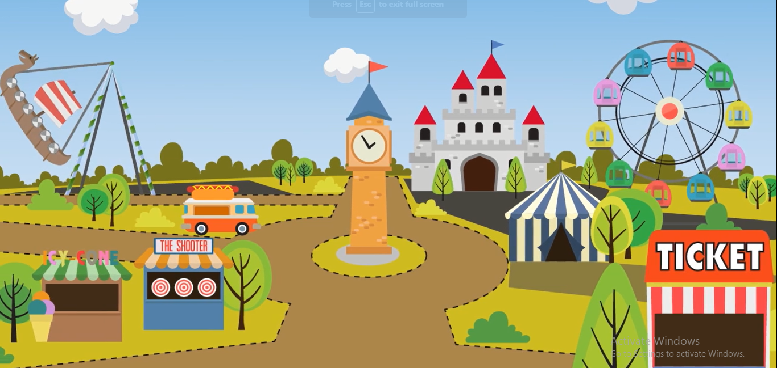
In Jericho Tiger Park
We went by bus and played all day
Until the sky was dark.
On Sunday we weren't at the beach
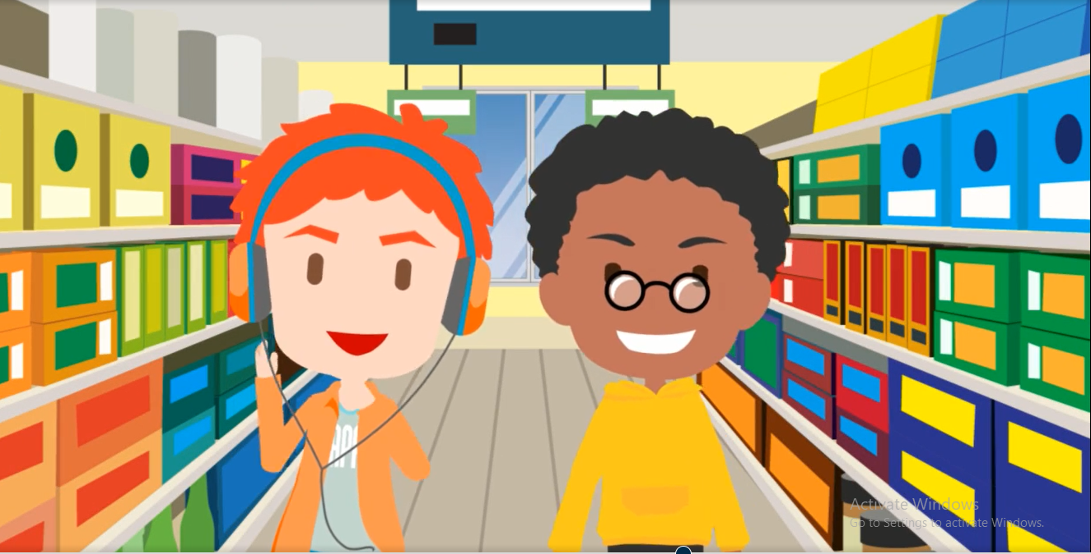
I wasn't in the park
We were at the shops all day
Until the sky was dark.
On Monday I was back at school
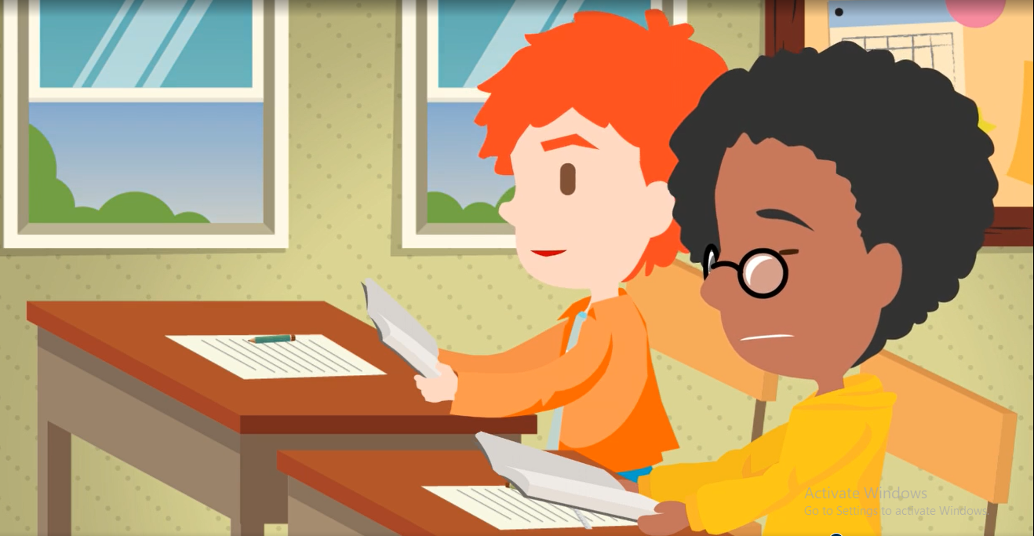
I sat next to my friend Baraa
We studied hard all day
Until the sky was dark.
Adapted from a British Council Resource “I was at the Seaside”

Exercise: Answer the following questions using full sentences.

- Where was Ali on Friday? ______________________________________________

- Who was Ali with? ____________________________________________________

- What did they do on Friday? _____________________________________________

- Where did Ali go on Saturday? ___________________________________________

- How did they go there? __________________________________________________

- What did Ali and his friend go on Sunday? ___________________________________

- What did Ali and his friend do at school on Monday? ______________________________

- Find the past tense of the following verbs from the text:

Present | Past
am
are
go
play
sit
study

Spelling

sat | wore | went | ate | was
married | were | saw | studied | played

Exercise 1: Write the words in the correct boxes:

Exercise 2: Unscramble the letters to spell the words correctly:
E.g. asw was

wree | Tae | diarerm
twen | asw | eowr
ast | leaydp | usddeit

