Rapunzel
An Old Tale
Summary:
Rapunzel is a princess locked up in a tower by a wicked witch. The tower has no entrance so Rapunzel lets down her very long hair every time the witch was to come up. One day, a noble prince hears Rapunzel’s voice as she was singing in the tower and then sees the wicked witch climb up the tower using Rapunzel’s hair. The prince finally marries Rapunzel and they live happily ever after.

Speaking and Listening:

In pairs or groups imagine that Rapunzel was mute, how do you think the prince might notice her presence in the tower?

Reading and Writing:
Read the following poem:
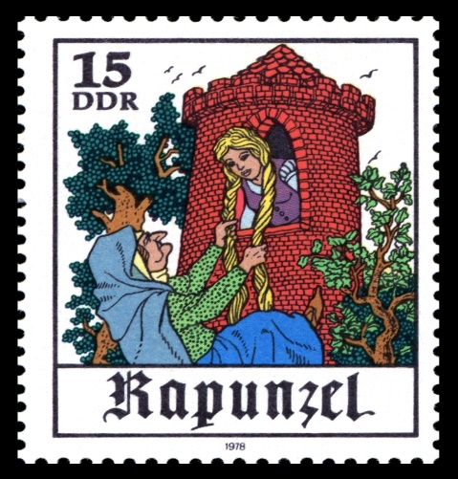
Rapunzel was a girl with hair of gold
Trapped in a tower in days of old
She wasn’t allowed outside to play
And her golden hair grew longer each day
The witch who locked her up was mean
With a pointed nose and a face of green

Using the table below, find all the simple past verbs and decide whether they are regular verbs or irregular verbs

Simple Past (Regular) | Simple Past (Irregular)

Arts and Crafts:

Using a Paper Towel Roll, make a tower and draw Rapunzel on it. Use yellow wool strips for her hair and glue it to her head, making sure it is long enough to reach the very bottom of the tower. You have the option of braiding her hair or leaving it unbraided! Have Fun!

